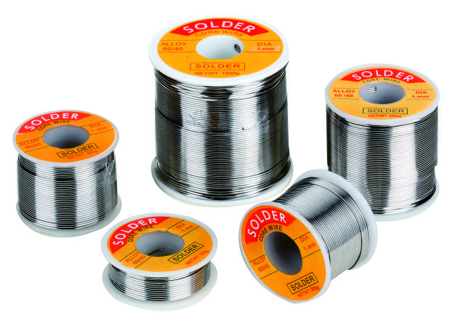
Soldering Wire
Model: NS3005

Specification:
60%SN/40%PB, Flux:2%
OD:0.71mm
New weight: 200g
Melting point: 183℃

