Spiral Binding for Cables
Keep wiring tidy! Spiral binding is available in 2 sizes, and is easily wrapped around bunches of cables to keep them tidy.

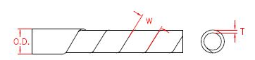

Item Code | O.D | W | T
HP1218 | 4.5 | 6.7+/-1 | 0.6+/-0.1
HP1219 | 12 | 15.0+/-1.5 | 0.85+/-0.1
HP1220 | 4.5 | 6.7+/-1 | 0.6+/-0.1
HP1222 | 12 | 15.0+/-1.5 | 0.85+/-0.1

