**GE4142**

**4 in 1 Multimedia Player, with Magnetic Cartridge**

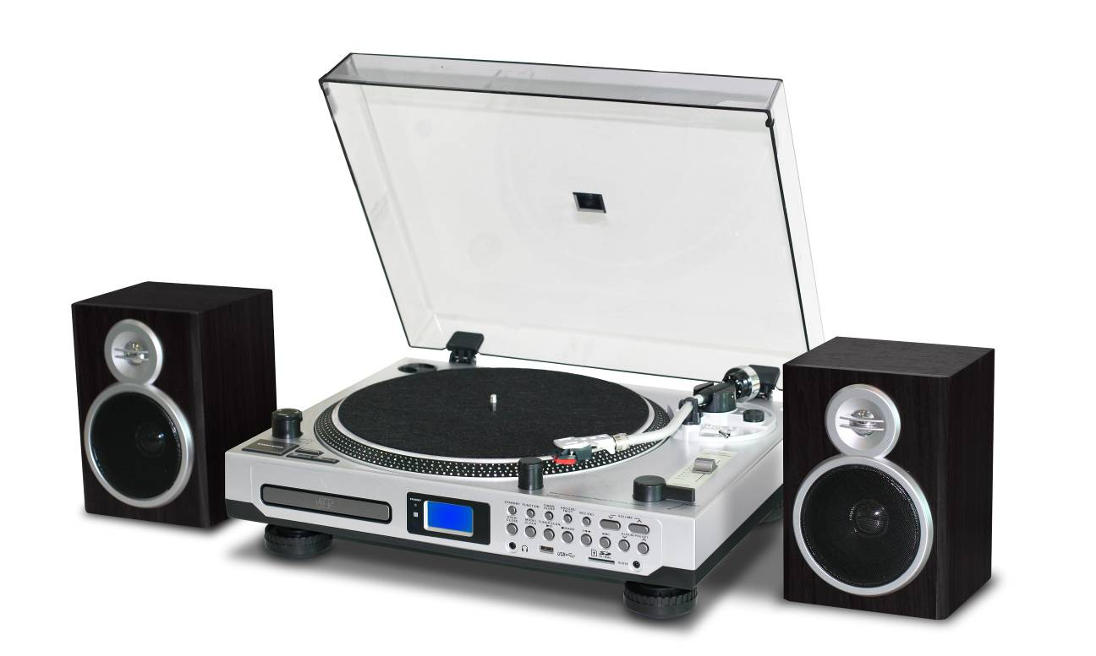

**INSTRUCTION MANUAL**

*READ THIS INSTRUCTION MANUAL CAREFULLY BEFORE USE*

# PRODUCT FEATURES

* 33/45 RPM SELECTABLE TURNTABLE
* BELT DRIVEN SYSTEM
* PRORAMMABLE CD/MP3 PLAYER
* DIRECT USB/SD ENCODING FOR CD, TURNTABLE, FM RADIO & AUX IN
* AUX IN FOR CONNECTION OF OTHER DEVICE (EG. CD & MP3 PLAYER)
* USB/SD SLOT FOR MP3 PLAYBACK
* PLL RADIO WITH PRESET 20 AM & 30 FM STATIONS
* CLOCK / SLEEP / TIMER FUNCTION
* LCD DISPLAY WITH BLUE BACKLIGHT
* RCA LINE-OUT
* EXTERNAL 2 X 4W SPEAKER BOX
* 45RPM ADAPTOR & REMOTE CONTROL
* +/- 10% PITCH CONTROL
* ACCESSORIES INCLUDED:

1. TURNTABLE PLATTER
2. TURNTABLE SILICON MAT
3. DUST COVER
4. 45 RPM ADAPTOR
5. COUNTERWEIGHT
6. HEADSHELL
7. AUDIO TECHNICA CARTRIDGE
8. REMOTE CONTROL
9. OPERATION MANUAL

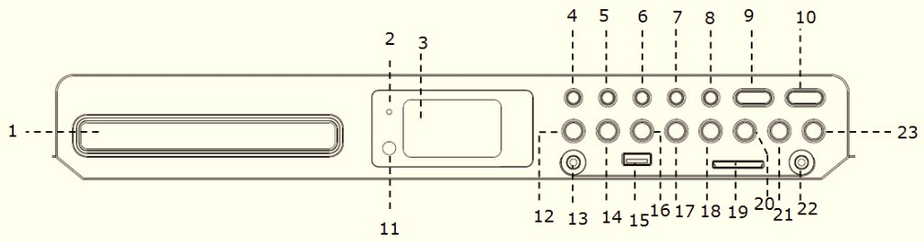

# LOCATION OF CONTROL

1. CD DOOR
2. STANDBY INDICATOR
3. LCD DISPLAY
4. STANDBY
5. FUNCTION
6. TIMER/SLEEP
7. SNOOZE/FM ST.
8. 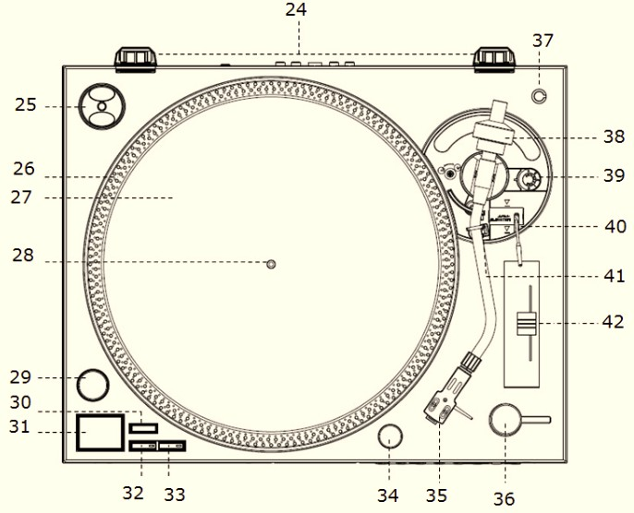REC / DEL
9. VOLUME DOWN
10. VOLUME UP
11. REMOTE CONTROL RECEIVER
12. CD OPEN / CLOSE
13. EARPHONE JACK
14. MODE / CLOCK
15. USB SOCKET
16. TUNER SCAN / PLAY/PAUSEPLAY,PAUSE,STOP
17. STOPPLAY,PAUSE,STOP / BAND BUTTON
18. SKIP DOWN**symbol skip 1**
19. SD/MMC CARD SLOT
20. SKIP UPsymbol skip 2
21. ALBUM / PRESET DOWN
22. AUX IN JACK
23. ALBUM / PRESET UP
24. HINGE FOR DUST COVER
25. 45 RPM ADAPTOR
26. STROBE DOTS
27. SLIP MAT
28. CENTER SPINDLE
29. POWER SWITCH / STROBE
30. TARGET LIGHT SWTICH
31. START / STOP BUTTON
32. 33RPM SPEED SELECT BUTTON
33. 45RPM SPEED SELECT BUTTON
34. 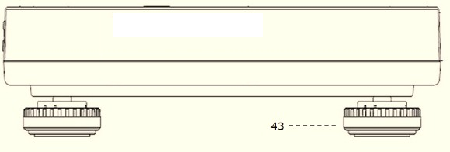TARGET LIGHT
35. HEADSHELL
36. EJECT
37. POSITION FOR PREPARING CARTRIDGE
38. COUNTERWEIGHT
39. ANTI-SKATE KNOB
40. LIFT LEVER
41. TONE ARM REST PART
42. 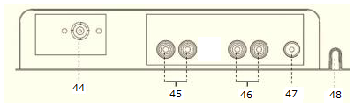PITCH CONTROL SLIDER (+/- 10%)
43. TURNTABLE FOOT
44. FM WIRE ANTENNA
45. SPEAKER SOCKET
46. LINE-OUT SOCKET
47. GROUND TERMINAL
48. AC POWER CORD

**CAUTION:**

USAGE OF CONTROLS OR ADJUSTMENTS OR PERFORMANCE OF PROCEDURES OTHER THAN THOSE SPECIFIED HEREIN MAY RESULTE IN HAZARDOUS RADIATION EXPOSURE.

THIS UNIT SHOULD NOT BE ADJUSTED OR REPAIRED BY ANYONE EXCEPT QUALIFIED SERVICE PERSONNEL.

**WARNING:**

* THE APPARATUS SHALL NOT BE EXPOSED TO DRIPPING OR SPLASHING AND THAT NO OBJECTS FILLED WITH LIQUIDS, SUCH AS VASES, SHALL BE PLACED ON THE APPARATUS.
* BATTERIES (BATTERY PACK OR BATTERIES INSTALLED) SHALL NOT BE EXPOSED TO EXCESSIVE HEAT SUCH AS SUNSHINE, FIRE OR THE LIKE.
* THE MAINS PLUGS OR AN APPLIANCE COUPLER IS USED AS THE DISCONNECT DEVICE, AND THE DISCONNECT DEVISE SHALL REMAIN READILY OPERABLE.

## PRECAUTIONS FOR USE

### INSTALLATION

1. UNPACK ALL PARTS AND REMOVE PROTECTIVE MATERIAL.
2. DO NOT CONNECT THE UNIT TO THE MAINS BEFORE CHECKING THE MAINS VOLTAGE AND BEFORE ALL OTHER CONNECTIONS HAVE BEEN MADE.
3. DO NOT COVER ANY VENTS AND MAKE SURE THAT THERE IS A SPACE OF SEVERAL CENTIMETERS AROUND THE UNIT FOR VENTILATION.

**CONNECTION**

1. PLUG THE UNIT INTO A SUITABLE MAINS SOCKET
2. CONNECT SPEAKER BOX WITH **SPEAKER SOCKET**
3. TURN THE **POWER SWTICH** CLOCKWISE TO ENTER TO STANDBY MODE, **STANDBY INDICATOR** WILL BE ON. THE STROBE ILLUMINATOR WHICH IS LOCATED BENEATH THE SWTICH WILL LIGHT UP.
4. PUSH THE **STANDBY BUTTON**, **STANDBY INDICATOR** WILL BE OFF, UNIT IS READY FOR OPERATION.

# SETTING THE CLOCK

1. WHEN THE **STANDBY INDICATOR** LIGHTS UP, THE UNIT IS IN THE STANDBY MODE.
2. DURING STANDBY MODE, SELECT BETWEEN 12H OR 24H CLOCK OPTIONS:
3. PRESS AND HOLD **MODE BUTTON** FOR 3-5 SECONDS; 12H / 24H WILL BE FLASHING. PRESS **SKIP DOWNsymbol skip 1 BUTTON** OR **SKIP UPsymbol skip 2 BUTTON** TO SELECT 12H / 24H MODE. PRESS **MODE BUTTON** AGAIN TO CONFIRM.
4. SETTING HOUR: PRESS **SKIP DOWNsymbol skip 1 BUTTON** OR **SKIP UPsymbol skip 2 BUTTON** TO SELECT THE CORRECT HOUR. PRESS **MODE BUTTON** AGAIN TO CONFIRM.
5. SETTING MINUTE: AFTER STEPS 2 & 3 ARE COMPLETED, PRESS **SKIP DOWNsymbol skip 1 BUTTON** OR **CD 1 - SKIP UPsymbol skip 2 BUTTON** TO SELECT CORRECT MINUTE. PRESS **MODE BUTTON** AGAIN TO CONFIRM.

## SETTING ALARM

1. DURING STANDBY MODE, HOLD **TIMER BUTTON** FOR 3-5 SECONDS. SETTING THE ALARM SEQUENCE IS “ALARM ON TIME > ALARM OFF TIME > ALARM MODE > ALARM VOLUME”.
2. SETTING ALARM ON TIME: “ON” IS ILLUMINATED ON THE DISPLAY
   * 1. SETTING HOUR: PRESS **SKIP DOWNsymbol skip 1 BUTTON** OR **SKIP UPsymbol skip 2 BUTTON** TO SELECT THE CORRECT HOUR, THEN PRESS **TIMER BUTTON** AGAIN TO CONFIRM.
     2. SETTING MINUTE: PRESS **SKIP DOWNsymbol skip 1 BUTTON** OR **SKIP UPsymbol skip 2 BUTTON** TO SELECT THE CORRECT MINUTE, THEN PRESS **TIMER BUTTON** AGAIN TO CONFIRM
3. SETTING ALARM OFF TIME: “OFF” IS ILLUMINATED ON THE DISPLAY:
   * 1. SETTING HOUR: PRESS **SKIP DOWNsymbol skip 1 BUTTON** OR **SKIP UPsymbol skip 2 BUTTON** TO SELECT THE CORRECT HOUR, THEN PRESS **TIMER BUTTON** AGAIN TO CONFIRM.
     2. SETTING MINUTE: PRESS **SKIP DOWNsymbol skip 1 BUTTON** OR **SKIP UPsymbol skip 2 BUTTON** TO SELECT THE CORRECT MINUTE, THEN PRESS **TIMER BUTTON** AGAIN TO CONFIRM.
4. SETTING ALARM MODE: “TUNE”, “CD”, “USB” OR “CARD” IS ILLUMINATED ON THE DISPLAY:
   * 1. PRESS **SKIP DOWNsymbol skip 1 BUTTON OR SKIP UPsymbol skip 2 BUTTON** TO SELECT THE ALARM MODE, THEN PRESS **TIMER BUTTON** AGAIN TO CONFIRM.
     2. “TUNE”, “CD-1”, “USB” OR “CARD” (=SD CARD) ARE AVAILABLE FOR ALARM MODE SELECTION.
5. SETTING ALARM VOLUME: “V - ” IS ILLUMINATED ON THE DISPLAY:
   * 1. PRESS **SKIP DOWNsymbol skip 1 BUTTON OR SKIP UPsymbol skip 2 BUTTON** TO SELECT THE ALARM VOLUME, THEN PRESS **TIMER BUTTON** AGAIN TO CONFIRM.
6. WHEN SETTING THE ALARM IS COMPLETE, THE DISPLAY WILL SHOW THE SETTING AGAIN FOR CLARIFICATION.
7. “CLOCK” ICON WILL BE FLASHING WHEN ALARM IS IN ACTIVE. “CLOCK” ICON LIGHTS UP WHEN ALARM SETTING IS STORED BUT NOT IN ACTIVE YET.
8. CANCEL ALARM: DURING STANDBY MODE, WHEN “CLOCK” ICON IS ON, PRESS **TIMER BUTTON**, “CLOCK” ICON WILL TURN OFF.

## SNOOZE FUNCTION

PRESS **SNOOZE** BUTTON WHEN ALARM IN ACTIVE, ALARM WILL BE SLIENT FOR 10 MINUTES. AFTER 10-MINUTUE SNOOZE INTERVAL, ALARM WILL BE ACTIVE AGAIN. SNOOZE CAN BE USED FOR REPEATEDLY WITHIN THE 1-HOUR ALARM ACTIVE INTERVAL.

## TIMER FUNCTION

1. WHEN THE UNIT IS TURNED ON (STANDBY INDICATOR LIGHT IS OFF), PRESS **SLEEP BUTTON** REPEATEDLY TO CHOOSE THE DESIRED SLEEP TIME MINUTES FROM 90>80>70…..>10 OFF.
2. SLEEP TIME SETTING IS STORED WHEN THE “SLEEP” ICON LIGHTS UP ON THE DISPLAY.

# LISTENING TO RADIO & RECORDING TO USB/SD

## NOTE: IT IS RECOMMENDED THAT A 4GB MEMORY STICK IS USED WHEN RECORDING TO USB

**RADIO TUNING**

1. PRESS **FUNCTION BUTTON** TO SELECT “TUNE” MODE.
2. SELECT THE DESIRED BAND BY RADIO **BAND BUTTON** (AM OR FM).
3. TUNE TO THE REQUIRED STATION BY PRESSING **SKIP UP OR SKIP DOWN BUTTON** FOR 1-2 SECONDS, AND THEN RELEASE.
4. RADIO FREQUENCY CAN ALSO BE ADJUSTED MANUALLY BY PRESSING AND RELEASING **SKIP UP OR SKIP DOWN BUTTON** IMMEDIATELY.
5. THE UNIT WILL START SEEKING AUTOMATICALLY AND STOP WHEN A RADIO STATION IS FOUND.

**MANUAL PRESET RADIO STATIONS**

1. WHEN THE DESIRED RADIO STATION IS FOUND, PRESS **MODE BUTTON**, PROGRAM NUMBER WILL BE FLASHING.
2. PRESS **PRESET UP OR PRESET DOWN** TO CHOOSE THE PROGRAM NUMBER FOR STORING THE DESIRED RADIO STATION.
3. PRESS **MODE BUTTON** AGAIN TO CONFIRM, PROGRAM NUMBER WILL STOP TO FLASH.
4. REPEAT STEP 2 & 3 UNTIL ALL DESIRED RADIO STATIONS IS BEING FOUND AND STORED
5. PRESS **PRESET UP OR PRESET DOWN** TO CHOOSE THE PRESE RADIO STATIONS.
6. THE NUMBER OF STATIONS CAN BE FOUND AND STORED IS DEPENDED ON THE RECEPTION OF DIFFERENT AREA AND COUNTRIES.

**ATUO PRESET RADIO STATIONS**

1. DURING RADIO MODE, PRESS THE **PLAY/PAUSE BUTTON**, THE UNIT WILL AUTOMATICLLY SCAN THE RADIO FREQUENCY. WHEN THE CLEAR SIGNAL IS FOUND, IT WILL AUTOMATICALLY STORE THE RADIO STATION, STARTING FROM PROGRAM NUMBER 1.
2. THE NUMBER OF STATIONS CAN BE FOUND AND STORED IS DEPENDED ON THE RECEPTION OF DIFFERENT AREA AND COUNTRIES.

**FM & FM-STEREO RADIO RECORDING TO USB/SD**

1. PRESS **FUNCTION BUTTON** TO SELECT “TUNE” MODE AND SELECT THE DESIRED BAND BY **BAND BUTTON** (AM OR FM).
2. INSERT MEMORY DEVICE (USB DRIVE, SD OR MMC CARD)
3. PRESS THE **REC BUTTON**; IT WILL TAKE 3-5 SECONDS TO READ MEMORY DEVICE. THEN USB OR SD ICON WILL BE FLASHING.
4. PRESS **SKIP UP symbol skip 2** OR **SKIP DOWN symbol skip 1 BUTTON** TO SELECT DESIRED MODE (USB OR SD) FOR ENCODING. THEN PRESS **REC BUTTON** AGAIN TO CONFIRM. AND THE SYSTEM IS STARTING THE ENCODING MODE AFTER FEW SECONDS.
5. IF ONLY USB DRIVE, SD OR MMC CARD IS INSERTED, STEP 4 CAN BE SKIPPED.
6. THE USB OR SD ICON WILL BE FLASHING ON THE DISPLAY DURING ENCODING.
7. TO FINISH RECORDING, PRESS **REC BUTTON** AGAIN AND DISPLAY WILL SHOW “END” AND RETURN TO TUNER MODE.

**PHONO & ENCODING**

**NOTED:**

* INSTALL THE DUST COVER INTO HINGE ON THE UPPER CABINET.

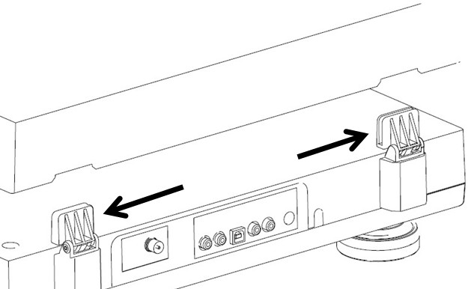

* SET THE TURNTABLE PLATTER ONTO THE **CENTER SPINDLE.**

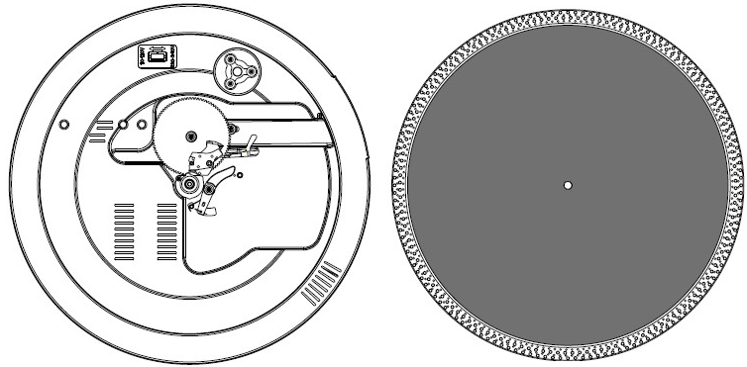

* ATTACH THE DRIVE BELT: POSITION THE BELT ON THE MOTOR PULLY, THE DRIVE BELT IS TIGHTENED UNDER THE TURNTABLE PLATTER.

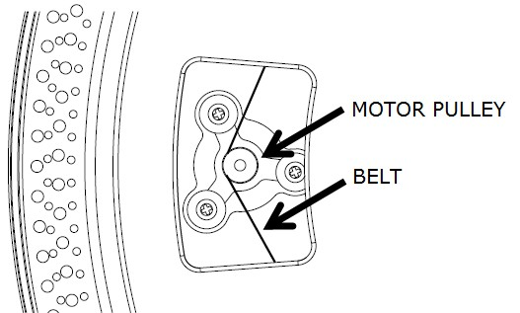

* PLACE THE SLIP MAT ON THE TURNTABLE PLATTER.
* INSERT THE **HEADSHLL** INTO THE FRONT END OF THE TONEARM, THEN SCREW THE LOCK NUT WITH THE **HEADSHELL** FIRMLY HELD HORIZONTALLY.
* 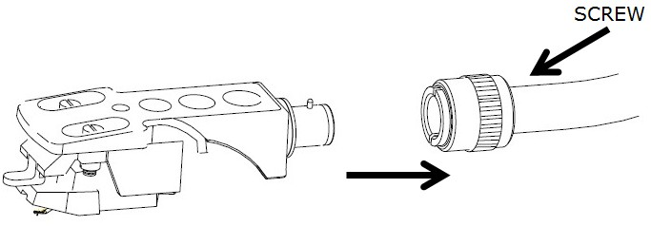
* SLIDE **COUNTERWEIGHT** ONTO THE TONEARM. TWIST IT LIGHTLY AND IT WILL SCREW INWARDS ONTO THE REAR END OF THE **TONEARM**.

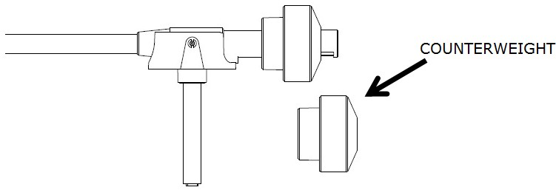

* FOR THE DEFAULT AUDIO-TECHNICA AT-3600L CARTRIDGE, TURN THE CUONTERWEIGHT INWARD TILL IT REACH THE HORIZONTAL LINE AS BELOW:

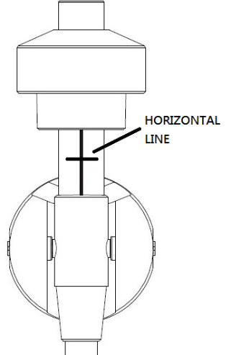

* FOR OTHER CARTRIDGE, USER CAN ADJUST THE TRACKING FORCE BY TURNING COUNTERWEIGHT INWARDS OR BACKWARDS. TURN THE CUONTERWEIGHT INWARD TILL IT REACH THE HORIZONTAL LINE. HOLD THE **COUNTER WEIGHT** WITH ONE HAND, TURN SCALE RING TO “0” AGAINST THE INDEX LINE ON THE SHAFT WITH ANOTHER HAND, BE SURE NOT TO TURN TOGETHER WITH THE **COUNTERWEIGHT**

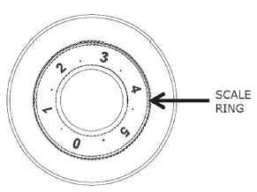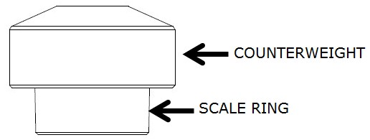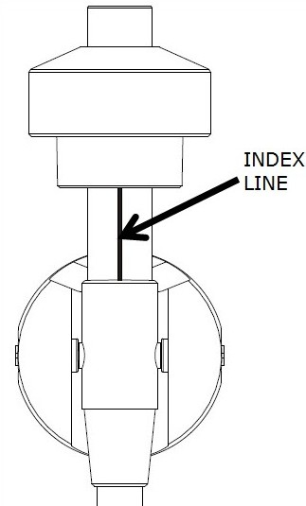

* THE NUMBER ON THE SCALE RING CORRESPOND TO AROUND 0.4G OF TRACKING FORCE. TURNING THE **COUNTERWEIGHT** INWARD CAN DECREASE THE FORCE, WHILE TURNING THE **COUNTERWEIGHT** BACKWARD CAN INCREASE THE FORCE.
* 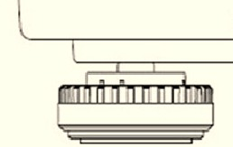TURNTABLE FOOT CAN BE TURNED CLOCK-WISE OR COUNTER CLOCK-WISE TO MAKE THE TURNTABLE BALANCED.

**LEVEL BALANCE ADJUSTMENT**

* SET THE ANTI-SKATE KNOB TO “0”.
* HOLD THE **HEADSHELL**’S FINGER-LIFT WITH ONE HAND AND ACHIEVE “LEVEL BALANCE” BY TURNING THE **COUNTERWEIGHT** EITHER CLOCKWISE OR COUNTER CLOCK WISE. “LEVEL BALANCE” MEANS THE TONEARM IS PARALLEL TO THE RECORD ON THE PLATTER, AND THAT THE TONEARM PIPE SHOULD NOT TILT TOWARDS THE **COUNTERWEIGHT** SIDE OF THE HEADSHELL SIDE

**TONEARM PROPERLY BALANCED:**

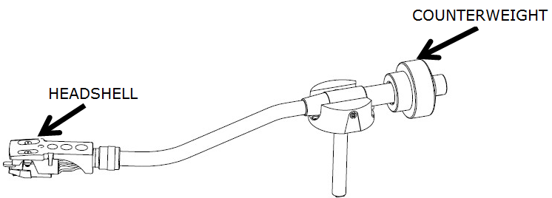

**COUNTERWEIGHT END IS TOO HEAVY, TURN THE COUNTERWEIGHT COUNTER-CLOCK WISE TO ADJUST:**

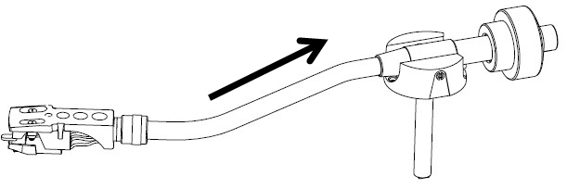

**HEADSHELL END IS TOO HEAVY, TURN THE COUNTERWEIGHT CLOCK-WISE TO ADJUST:**

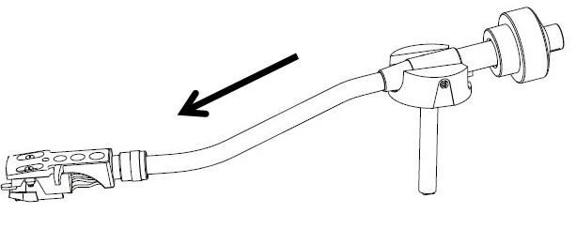

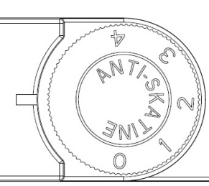

**ANTI-SKATING ADJUSTMENT**

TO ADJUST THE ANTI SKATING MECHANISM, TURN THE ANTI-SKATE KNOB TILL

THE INDEX LINE AGAINST “0”. TURN THE ANTI-SKATE KNOB TO ADJUST

TRACKING FORCE IF NECESSARY.

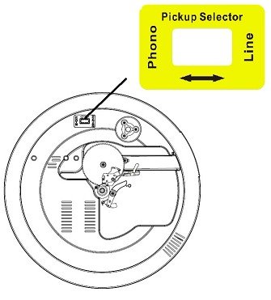**PICKUP SELECTOR**

* PICKUP SELECTOR IS LOCATED ON THE TURNTABLE DECK.
* SELECT “PHONO” FOR BUILT-IN PRE-AMPLIFIIER, OR SELECT “LINE” FOR CONNECTION WITH SUITABLE EXTERNAL PRE-AMPLIFIER VIA **RCA JACK**.
* IF CHANGE TO OTHER NEEDLE OR CARTRIDGE, PUT A SCREW DRIVER INTO PICKUP SELECTOR TO SELECT “LINE”. IN THIS CASE, CONNECT THE PRODUCT WITH SUITABLE EXTERNAL AMPLIFIER (DEPENDS ON THE SPECIFICATION OF THE OTHE NEEDLE OR CARTRIDGE) VIA **RCA JACK.**
* PRESS **FUNCTION BUTTON** TO SELECT “PHON” ON DISPLAY.
* REMOVE THE STYLUS PROTECTOR.
* BE SURE THAT THE TONE ARM IS BEING DETACHED FROM THE **TONE ARM REST** **PART** BEFORE OPERATING AND RE-SECURED AGAIN AFTERWARDS.
* PUSH THE **LIFT LEVER** UPWARD TO RAISE THE TONE ARM FROM THE ARM PARK, AND THEN SLOWLY MOVE IT TO THE RECORD SIDE. THE PLATTER WILL START TO ROTATE.
* PUT DOWN THE **LIFT LEVER** TO DROP THE TONE ARM AND TOUCH THE RECORD GENTLY. PHONO PLAYING STARTS NOW.
* PUSH THE **LIFT LEVER** UPWARD TO RAISE THE TONE ARM FROM THE ARM PARK, NOW PLATTER WILL STILL BE ROTATING BUT PHONO PLAYING WILL STOP. TO CONTINUE THE PLAYING, THE USER NEEDS TO PUT DOWN THE **LIFT LEVER**.
* PRESS **33RPM SPEED SELECT OR 45RPM SPEED SELECT BUTTON** DEPENDING ON THE RECORD TO BE PLAYED, BUTTON INDICATOR WILL LIGHT UP.
* PRESS **START / STOP BUTTON,** TURNTABLE WILL STOP ROTATING GENTLY. PRESS **START / STOP BUTTON,** TURNTABLE WILL ROTATE AGAIN.
* **STROB DOTS** ON THE TURNTABLE PLATTER FOR SPEED CHECKING. UPPER TWO ROWS FOR 50HZ, LOWER TWO ROWS FOR 60HZ. BIGGER DOTS FOR 45RPM, SMALLER DOTS FOR 33RPM. SUITABLE DOTS WILL KEEP STABLIZED IF THE SPEED IF CORRECT. ADJUST SPEED BY **PITCH CONTROL SLIDER (+/-10%)**.
* PRESS **TARGET LIGHT SWTICH, TARGET LIGHT** WILL LIGHT UP; PRESS **TARGET LIGHT SWTICH AGAIN, TARGET LIGHT** WILL BE OFF.
* USE THE 45 RPM ADAPTOR IF REQUIRED.
* ADJUST THE VOLUME TO THE DESIRED LEVEL.
* AT THE END OF RECORD, THE PLATTER WILL AUTOMATICALLY STOP ROTATING, TONE ARM WILL AUTOMATICALLY RETURN TO THE **TONE ARM REST PART.** TRIGGER THE **EJECT** SWITCH DURING RECORD PLAYING, TURNTABLE WILL STOP GENTLY AND TONE ARM WILL UTOMATICALLY RETURN TO THE **TONE ARM REST PART.**

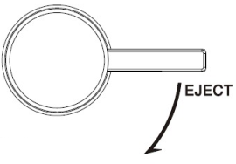

**PHONO ENCODING**

1. PRESS **FUNCTION BUTTON** TO SELECT “PHON” ON DISPLAY AND THEN INSERT MEMORY DEVICE (USB DRIVE, SD OR MMC CARD).

2.PRESS THE **REC BUTTON**, IT WILL TAKE 3-5 SECONDS TO READ MEMORY DEVICE. THEN USB OR SD ICON WILL BE FLASHING.

3.PRESS **SKIP UP symbol skip 2 BUTTON OR SKIP DOWN symbol skip 1 BUTTON** TO SELECT DESIRED MODE (USB OR SD) FOR ENCODING. THEN PRESS THE **REC BUTTON** AGAIN TO CONFIRM. AND THE SYSTEM IS STARTING THE ENCODING MODE AFTER FEW SECONDSS.

4. IF ONLY USB DRIVE OR SD/MMC CARD IS INSERTED, STEP 3 CAN BE SKIPPED.

5.THE USB OR SD ICON WILL BE FLASHING ON THE DISPLAY DURNIG ENCODING.

5.TO FINISH ENCODING, PRESS **STOP PLAY,PAUSE,STOP BUTTON** AND DISPLAY WILL SHOW “END” AND RETURN TO PHONO MODE.

**REMARK:-**

* THE RECORDING SPEED IS 1:1 AND ACCORDING TO THE ACTUAL PLYING TIME OF THE PHONO
* THE RECORDING FORMAT IS PRESET AT – MP3 BIT RATE : 128 KBPS

**AUX IN JACK & ENCODING**

PRESS **FUNCTION BUTTON** TO SELECT “AUX” ON DISPLAY, THEN CONNECT THE EXTERNAL AUDIO DEVICE (SUCH AS CD PLAYER) THROUGH THE **AUX IN JACK**. AUDIO SIGNAL FROM THE EXTERNAL AUDIO DEVICE CAN BE PLAYED THROUGH THE SYSTEM.

**AUX IN ENCODING**

1. PRESS **FUNCTION BUTTON** TO SELECT “AUX” ON DISPLAY, THEN INSERT MEMORY DEVICE (USB DRIVE, SD OR MMC CARD)

2.PRESS THE **REC BUTTON**, IT WILL TAKE 3-5 SECONDSS TO READ MEMORY DEVICE. THEN USB OR SD ICON WILL BE FLASHING.

3.PRESS **SKIP UP symbol skip 2 BUTTON OR SKIP DOWN symbol skip 1 BUTTON** TO SELECT DESIRED MODE (USB OR SD) FOR ENCODING. THEN PRESS THE **REC BUTTON** AGAIN TO CONFIRM. AND THE SYSTEM IS STARTING THE ENCODING MODE AFTER FEW SECONDS.

4.IF ONLY USB DRIVE OR SD/MMC CARD IS INSERTED, STEP 3 CAN BE SKIPPED.

5.THE USB OR SD ICON WILL BE FLASHING ON THE DISPLAY DURNIG ENCODING.

6.TO FINISH ENCODING, PRESS **STOP PLAY,PAUSE,STOP BUTTON** AND DISPLAY WILL SHOW “END” AND RETURN TO “AUX” MODE.

**REMARK:-**

* THE RECORDING SPEED IS 1:1 AND ACCORDING TO THE ACTUAL PLYING TIME OF THE EXTERNAL AUDIO DEVICE.
* THE RECORDING FORMAT IS PRESET AT – MP3 BIT RATE : 128 KBPS

# PLAYBACK OF MP3/WMA SONG VIA USB STORAGE MEDIA OR MEMORY CARD

## CONNECTING

THE SYSTEM IS ABLE TO DECODE AND PLAYBACK ALL MP3 / WMA FILE WHICH STORED IN THE MEMORY MEDIA WITH USB CONNECTING PORT OR SD/MMC MEMORY CARD.

1. PLUG-IN THE USB PLUG WITH THE FACE UP & MAKE SURE IT GOING INTO COMPLETELY OR INSERT THE MEMORY CARD IN THE DIRECTION OF THE ARROW AS SHOWN IN THE LABEL ON THE UNDERSIDE OF THE MEMORY CARD SLOT COVER. INSERT STRAIGHT WITHOUT BENDING.
2. CONNECTING THE USB UPSIDE DOWN OR BACKWARDS COULD DAMAGE THE AUDIO SYSTEM OR THE STORAGE MEDIA (USB THUMB DRIVE / SD/MMC CARD). CHECK TO BE SURE THE DIRECTION IS CORRECT BEFORE CONNECTION.

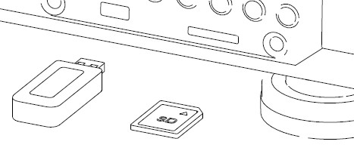

1. PRESS **FUNCTION BUTTON** TO SELECT “USB” OR “CARD” ON DISPLAY, THEN INSERT MEMORY DEVICE (USB DRIVE, SD OR MMC CARD).
2. THE SYSTEM WILL START READING THE STORAGE MEDIA AUTOMATICALLY AFTER FUNCTION SELECTION, AND DISPLAY WILL SHOW THE TOTAL NUMBER OF MP3/WMA FILES (EG. 016).
3. THEN THE SYSTEM WILL START AUDIO PLAYBACK FROM DESRIED DEVICE (USB OR SD/MMC) AUTOMATICALLY.

* **PLAY / PAUSE BUTTON PLAY,PAUSE,STOP**
* PRESS THE **PLAY/PAUSE PLAY,PAUSE,STOP BUTTON** ONCE TO HALT PLAYING, PRESS IT AGAIN TO CONTINUE.
* **STOP BUTTON** PLAY,PAUSE,STOP
* PRESS **STOP PLAY,PAUSE,STOP BUTTON** TO END UP AUDIO PLAYBACK, THEN DISPLAY WILL SHOW THE TOTAL NUMBER OF MP3/WMA FILES. AND THEN USER CAN PRESS **SKIP UP” symbol skip 2 OR SKIP DOWN symbol skip 1 BUTTON** TO SELECT FILE FORWARD OR BACKWARD.
* **SKIP UP symbol skip 2 / SKIP DOWN symbol skip 1 BUTTON**
* DURING MP3/WMA PLAYBACK, PRESS **SKIP UP symbol skip 2 BUTTON** ONCE TO PLAY THE NEXT FILE. PRESS AND HOLD **SKIP UP symbol skip 2 BUTTON** CONTINUOUSLY TO SPEED UP SELECTING FORWARD.
* DURING MP3/WMA PLAYBACK, PRESS **SKIP DOWN symbol skip 1 BUTTON** ONCE TO PLAY THE PREVIOUS FILE. PRESS AND HOLD **SKIP DOWN symbol skip 1 BUTTON** CONTINUOUSLY TO SPEED UP SELECTING BACKWARD.
* **FOLDER SEARCHING**

PRESS **ALBUM DOWN OR ALBUM UP** TO SEARCH FOLDER BACKWARD OR FORWARD.

* **REPEAT FUNCTION**

DURING AUDIO PLAYBACK, PRESS **MODE BUTTON** ONCE, SINGLE TRACK WILL BE PLAYED REPEATEDLY. PRESS **MODE BUTTON** AGAIN, IT WILL REPEATEDLY PLAY ALL TRACKS IN THE WHOLE USB DRIVE, SD OR MMC CARD.

**REMARK**

* IF CONNECT THE SYSTEM TO MP3 PLAYER VIA THE USB SOCKET, DUE TO VARIANCES IN MP3 ENCODING FORMAT, SOME MP3 PLAYER MAY NOT BE ABLE TO PLAY VIA THE USB SOCKET. THIS IS NOT A MALFUNCTION OF THE SYSTEM.
* THERE ARE NUMEROUS USB AND SD DEVICE PRODUCERS ARE. SOLUTION AND FORMAT ARE VARIABLE BETEEN EACH OTHER. THEREFORE, WE DO NOT GARANTTEE THIS UNIT CAN SUPPORT ALL USB AND SD DEVICE FROM EVERY BRAND.
* SD CARD CAN BE SUPPORED UP TO 8GB

## TRACKS PROGRAMMING

UP TO 60 TRACKS CAN BE PROGRAMMED FOR MP3/WMA FILE AND PLAY IN ANY ORDER. BEFORE USE, BE SURE THE SYSTEM IS AT STOP MODE BEFORE PROGRAMMING:

1. SET AT “USB” OR “CARD” FUNCTION, THEN PRESS **STOP BUTTON**.
2. PRESS **MODE BUTTON**, “MEM” WILL BE FLASHING ON LCD DISPLAY. MOREOVER, IT WILL INDICATE PROGRAM NO. AND DIGITS FOR TRACK NO. TO BE PROGRAMMED.
3. SELECT A DESIRED TRACK BY PRESSING **SKIP UP symbol skip 2 OR SKIP DOWN symbol skip 1 BUTTON**. IF FOLDER SELECTION IS REQUIRED, PRESSING **ALBUM DOWN OR ALBUM UP** TO SEARCH FOLDER BACKWARD OR FORWARD.
4. PRESS **MODE BUTTON** TO CONFIRM AND STORE THE TRACK INTO MEMORY.
5. REPEAT STEPS 3 AND 4 TO ENTER ADDITIONAL TRACKS INTO THE MEMORY IF NECESSARY.
6. WHEN ALL THE DESIRED TRACKS HAVE BEEN PROGRAMMED, PRESS **PLAY/PAUSE PLAY,PAUSE,STOP BUTTON** TO PLAY THE TRACKS IN ASSIGNED ORDER.
7. PRESS **STOP PLAY,PAUSE,STOP BUTTON** TO STOP PLAYING OF PROGRAMMED TRACKES, PRESS **STOP PLAY,PAUSE,STOP BUTTON** AGAIN TO CANCEL PROGRAMMING.

**COPYING OF MP3/WMA FILE**

* THE SYSTEM ALLOWS YOU TO COPY THE FILE FROM USB TO SD OR SD TO USB BY 1 FILE, 1 FOLDER OR ALL FILES.
* MP3/WMA FILE WILL BE COPIED IN HIGH SPEED FROM USB TO SD OR FROM SD TO USB DURING STOP MODE.

**I) COPY 1 TRACK**

* 1. INSERT THE USB STORAGE MEDIA OR SD/MMC CARD, SET IN “USB” OR “CARD” MODE.
  2. PRESS **REC BUTTON** DURING THE PLAYBACK OF THE COPYING TRACK, THEN “ONE” WILL BE FLASHING ON THE DISPLAY. PRESS **REC BUTTON** AGAIN TO CONFIRM.
  3. THE USB OR SD ICON WILL BE FLASHING ON THE DISPLAY. COPYING IS PERFORMING NOW.
  4. AFTER COMPLETING OF COPY, UNIT WILL STOP PLAYBACK AUTOMATICALLY.
  5. DISPLAY WILL SHOW “END” AND BACK TO USB OR SD MODE.

**II) COPY 1 FOLDER**

1.INSERT THE USB STORAGE MEDIA OR SD/MMC CARD, SET IN “USB” OR “CARD” MODE.

2. PRESS **ALBUM DOWN OR ALBUM UP** TO SEARCH DESIRED FOLDER FOR COPYING.

3. PRESS **REC BUTTON**, THEN “ONE” WILL BE FLASHING ON THE DISPLAY. PRESS **SKIP UP symbol skip 2 / SKIP DOWN symbol skip 1 BUTTON** TO SELECT “DIR” ON THE DISPLAY. PRESS **REC BUTTON** AGAIN TO CONFIRM.

4. USB OR SD ICON WILL BE FLASHING ON THE DISPLAY. COPYING IS PERFORMING NOW.

5. WHEN THE USB OR SD ICON STOPS FLASHING, IT MEANS THAT THE FOLDER COPYING IS COMPLETED.

**III) COPY ALL TRACK**

1.INSERT THE USB STORAGE MEDIA OR SD/MMC CARD, SET IN “USB” OR “CARD” MODE.

2. PRESS **REC BUTTON**, THEN “ONE” WILL BE FLASHING ON THE DISPLAY. **PRESS SKIP UP symbol skip 2 / SKIP DOWN symbol skip 1 BUTTON** TO SELECT “ALL” ON THE DISPLAY. PRESS **REC BUTTON** AGAIN TO CONFIRM.

4. USB OR SD ICON WILL BE FLASHING ON THE DISPLAY. COPYING IS PERFORMING NOW.

5. WHEN THE USB OR SD ICON WILL STOP FLASHING, IT MEANS THAT ALL TRACK COPYING IS COMPLETED.

REMARK:

* IF PRESS THE **REC BUTTON** DURING PLAYBACK OF USB OR SD MODE, THE FILE WILL COPY FROM USB TO SD OR SD TO USB.

# FILE DELETE FROM USB / SD CARD

THE SYSTEM IS ABLE TO ERASE THE FILE STORED INSIDE THE USB DRIVE OR SD CARD BY FOLLOWING:-

**I) DELETE 1 TRACK**

1. PRESS AND HOLD **DEL BUTTON** FOR 3-5 SECONDS DURING THE PLAYBACK OF THE DESIRED TRACK, THEN “ONE” WILL BE FLASHING ON THE DISPLAY. PRESS **DEL BUTTON** AGAIN TO CONFIRM.

2. “DEL” WILL BE SHOWN ON THE DISPLAY.

3. “DEL” WILL DISAPPEAR ON THE DISPLAY, IT MEANS THE TRACK IS DELETED.

**II) DELETE 1 FOLDER**

1. INSERT THE USB STORAGE MEDIA OR SD/MMC CARD, SET IN “USB” OR “CARD” MODE & SET AT STOP MODE AFTER UNIT READING.
2. PRESS **ALBUM DOWN OR ALBUM UP** TO SEARCH DESIRED FOLDER FOR DELETING.
3. PRESS AND HOLD **DEL BUTTON** FOR 3-5 SECONDS, “DEL” WILL SHOW ON THE DISPLAY. PRESS **SKIP UP symbol skip 2 / SKIP DOWN symbol skip 1 BUTTON** TO SELECT “DIR” ON THE DISPLAY. PRESS **DEL BUTTON** AGAIN TO CONFIRM.
4. “DEL” WILL BE SHOWN ON THE DISPLAY. AFTER “DEL” DISAPPEARS IT MEANS THE DESIRED FOLDER IS DELETED.

**II) DELETE ALL TRACK**

1. INSERT THE USB STORAGE MEDIA OR SD/MMC CARD, SET IN “USB” OR “CARD” MODE & SET AT STOP MODE AFTER UNIT READING.
2. PRESS AND HOLD **DEL BUTTON** FOR 3-5 SECONDS, THEN “ONE” WLL BE FLASHING ON THE DISPLAY. PRESS **SKIP UP symbol skip 2 / SKIP DOWN symbol skip 1 BUTTON** TO SELECT “ALL” ON THE DISPLAY. PRESS **DEL BUTTON** AGAIN TO CONFIRM.
3. USB OR SD ICON WILL BE FLASHING ON THE DISPLAY. DELETING IS PERFORMING NOW.
4. WHEN THE USB OR SD ICON STOPS FLASHING, IT MEANS THAT ALL TRACK COPYING IS COMPLETED.

**REMARK** : ALL THE FILES INSIDE THE USB STORAGE MEDIA OR SD CARD WILL BE DELETED COMPLETELY AFTER CONFIRMING TO “DEL” BUTTON.

## REMOVING OF USB / MEMORY CARD

TO REMOVE THE USB / MEMORY CARD, TURN OFF THE POWER OR SWITCH THE FUNCTION MODE TO EITHER CD, AUX OR TUNER FIRST. UN-PLUG IT BY PULLING OUT THE USB/CD SOCKET DIRECTLY.

# COMPACT DISC (CD) PLAYBACK & ENCODING

1. PRESS **FUNCTON BUTTON** TO “CD” MODE.

2. PRESS **CD OPNE/CLOSE BUTTON**, CD DOOR WILL BE OPENED, PUT THE CD IN THE TRAY AND PRESS **CD OPNE/CLOSE BUTTON** AGAIN, CD DOOR WILL BE CLOSED.

3.THE SYSTEM WILL START READING THE CD:

* **PLAY / PAUSE BUTTON PLAY,PAUSE,STOP**
* PRESS THE **PLAY/PAUSE PLAY,PAUSE,STOP BUTTON** ONCE TO HALT PLAYING, PRESS IT AGAIN TO CONTINUE.
* **STOP BUTTON** PLAY,PAUSE,STOP
* PRESS THE **STOP PLAY,PAUSE,STOP BUTTON** TO END UP AUDIO PLAYBACK, THEN DISPLAY WILL SHOW THE TOTAL NUMBER OF TRACKS. AND THEN USER CAN PRESS **SKIP UP symbol skip 2 OR SKIP DOWN symbol skip 1** BUTTON TO SELECT TRACKS.
* **SKIP UP symbol skip 2 / SKIP DOWN symbol skip 1 BUTTON**
* DURING CD PLAYBACK, PRESS **SKIP UP symbol skip 2 BUTTON** ONCE TO PLAY THE NEXT TRACK. PRESS AND HOLD **SKIP UP symbol skip 2 BUTTON** CONTINUOUSLY TO SPEED UP SELECTING FORWARD.
* DURING CD PLAYBACK, PRESS **SKIP DOWN” symbol skip 1 BUTTON** ONCE TO PLAY THE PREVIOUS TRACK. PRESS AND HOLD SKIP **DOWN**” **symbol skip 1** **BUTTON** CONTINUOUSLY TO SPEED UP SELECTING BACKWARD.
* **FOLDER SEARCHING**

PRESS **ALBUM DOWN OR ALBUM UP** TO SEARCH FOLDER BACKWARD OR FORWARD.

* **REPEAT FUNCTION**

DURING AUDIO PLAYBACK, PRESS **MODE BUTTON** ONCE, SINGLE TRACK WILL BE PLAYED REPEATEDLY. PRESS MODE BUTTON (5) AGAIN, IT WILL REPEATEDLY PLAY ALL TRACKS IN THE WHOLE CD.

## TRACKS PROGRAMMING

UP TO 60 MP3 TRACKS & 30 CD AUDIO FORMAT TRACK CAN BE PROGRAMMED AND PLAYED IN ANY ORDER. BEFORE USE, BE SURE THE SYSTEM IS AT STOP MODE BEFORE PROGRAMMING:

1. PRESS **FUNCTON BUTTON** TO “CD” AND AT STOP MODE

2.PRESS THE **MODE BUTTON**, “MEM” WILL BE FLASHING ON LCD DISPLAY. MOREOVER, IT WILL INDICATE PROGRAM NO. AND DIGITS FOR TRACK NO. TO BE PROGRAMMED.

3.SELECT A DESIRED TRACK BY PRESSING **SKIP UP symbol skip 2 OR SKIP DOWN symbol skip 1 BUTTON**. FOR MP3/WMA DISC, PRESSING **ALBUM DOWN OR ALBUM UP** TO SEARCH FOLDER BACKWARD OR FORWARD.

4.PRESS THE **MODE BUTTON** TO STORE THE TRACK INTO MEMORY.

5.REPEAT STEPS 3 AND 4 TO ENTER ADDITIONAL TRACKS INTO THE MEMORY IF NECESSARY.

6.WHEN ALL THE DESIRED TRACKS HAVE BEEN PROGRAMMED, PRESS **PLAY/PAUSE PLAY,PAUSE,STOP BUTTON** TO PLAY THE TRACKS IN ASSIGNED ORDER.

7. PRESS **STOP PLAY,PAUSE,STOP BUTTON** TO STOP PLAYING OF PROGRAMMED TRACKES, PRESS **STOP PLAY,PAUSE,STOP BUTTON** AGAIN TO CANCEL PROGRAMMING.

## CD RECORDING TO USB/SD

* THE SYSTEM ALLOWS YOU TO COPY THE TRACK FROM CD TO USB OR SD BY 1 TRACK, 1 FOLDER OR ALL FILES.
* MP3/WMA FILE WILL BE COPIED IN HIGH SPEED FROM CD TO USB/SD DURING STOP MODE.

**I) COPY 1 TRACK**

1.INSERT THE USB STORAGE MEDIA OR SD/MMC CARD, PRESS **FUNCTON BUTTON** TO “CD” MODE.

2.PRESS **REC BUTTON** DURING THE PLAYBACK OF THE COPYING TRACK FROM CD, THEN “ONE” WILL BE FLASHING ON THE DISPLAY. PRESS **REC BUTTON** AGAIN TO CONFIRM.

3.THE USB OR SD ICON WILL BE FLASHING ON THE DISPLAY. COPYING IS PERFORMING NOW.

4.AFTER COMPLETING OF COPY, UNIT WILL STOP PLAYBACK AUTOMATICALLY.

5.DISPLAY WILL SHOW “END” AND BACK TO CD MODE.

**II) COPY 1 FOLDER (FOR MP3/WMA DISC ONLY)**

1.INSERT THE USB STORAGE MEDIA OR SD/MMC CARD, SET IN CD & STOP MODE AFTER UNIT READING.

2. PRESS **ALBUM DOWN OR ALBUM UP** TO SEARCH FOLDER FOR COPYING.

3. PRESS **REC BUTTON**, THEN “ONE” WILL BE FLASHING ON THE DISPLAY. PRESS **SKIP UP symbol skip 2 / SKIP DOWN symbol skip 1 BUTTON** TO SELECT “DIR” ON THE DISPLAY. PRESS **REC BUTTON** AGAIN TO CONFIRM.

4. USB OR SD ICON WILL BE FLASHING ON THE DISPLAY. COPYING IS PERFORMING NOW.

5. WHEN THE USB OR SD ICON STOPS FLASHING, IT MEANS THAT THE FOLDER COPYING IS COMPLETED.

**III) COPY ALL TRACK**

1.INSERT THE USB STORAGE MEDIA OR SD/MMC CARD, PRESS **FUNCTON BUTTON** TO “CD” MODE.

2. PRESS **REC BUTTON**, THEN “ONE” WLL BE FLASHING ON THE DISPLAY. PRESS **SKIP UP symbol skip 2 / SKIP DOWN symbol skip 1 BUTTON** TO SELECT “ALL” ON THE DISPLAY. PRESS **REC BUTTON** AGAIN TO CONFIRM.

4. USB OR SD ICON WILL BE FLASHING ON THE DISPLAY. COPYING IS PERFORMING NOW.

5. WHEN THE USB OR SD ICON STOPS FLASHING, IT MEANS THAT ALL TRACK COPYING IS COMPLETED.

**SPLIT TRACK FUNCTION FOR USB/SD RECORDING FOR TURNTABLE**

**1)      MANUAL SPLIT OPERATION PROCEDURE:** DURING USB/SD RECORDING, THE USB/SD ICON WILL FLASH ON THE DISPLAY. IF A NEW TRACK IS REQUIRED, PRESS **MODE** BUTTON ON THE UNIT OR REMOTE CONTROL, DISPLAY WILL SHOW “TS”, THEN THE UNIT WILL STOP RECORDING MOMENTARILY AND RESUME AGAIN. A NEW FILE WILL HAVE BEEN CREATED ON THE USB/SD DEVICE REPRESNTING A NEW TRACK.

**2)      AUTO SPLIT OPERATION PROCEDURE:**

-          BEFORE USB/SD RECORDING, PRESS **FUNCT** BUTTON TO SELECT AUDIO SOURCE, THEN PRESS **MODE** BUTTON ON THE UNIT OR REMOTE CONTROL, DISPLAY WILL SHOW “T-ON”, WHICH MEANS THE AUTO SPLIT FUNCTION HAS ACTIVATED. THEN START USB/SD RECORDING, THE UNIT CAN AUTOMATICALLY DETECT THE SILENT PART BETWEEN EACH TRACK, AND CREATE A NEW FILE TO MOVE ON TO START RECORDING THE NEXT TRACK.

- IF NOT REQUIRED: PRESS **MODE** BUTTON ON THE UNIT OR REMOTE CONTROL BEFORE USB/SD RECORDING, DISPLAY WILL SHOW “T-OF”, WHICH MEANS AUTO SPLIT HAS BEEN DEACTIVATED.

- PLEASE NOTE FOR AUTO SPLIT: SEVERAL SECONDS OF THE BEGINNING OF THE NEXT TRACK MAY NOT BE RECORDED, AS THE UNIT MAY TAKE A FEW SECONDS TO CREATE A NEW FILE ON THE USB/SD; AND IT CAN ADDITIONALLY BE THE CASE THAT SOME MUSIC PRODUCERS INTENTIONALLY ADD SILENT SECTIONS WITHIN ONE TRACK. AS A RESULT, THIS WILL VERY LIKELY MAKE THE UNIT CONSIDER THIS SILENT PART THE BREAK BETWEEN TRACKS AND CREATE A NEW TRACK ON THE RECORDING.

- NOTE FOR AUTO SPLIT: DURING USB/SD RECORDING FROM TURNTABLE, WHEN THE UNIT HAS DETECTED ANY PARTICULAR SILENT PART, THE TURNTABLE WILL STOP MOMENTARILY. THE TURNTABLE WILL RESUME OPERATION ONCE THE USB/SD DEVICE HAS BEGUN CREATING A NEW FILE TO BE RECORDED.

**EARPHONE JACK & LINE OUT SOCKET**

* THIS SYSTEM CAN BE CONNECTED WITH HEADPHONE OR EXTERNAL AMPLIFIER / SPEAKER BY 3.5MM **EARPHONE JACK**.
* THIS SYSTEM CAN BE CONNECTED WITH EXTERNAL DEVICE (EG. ACTIVE AMPLIFIER AND SPEAKER) BY **LINE-OUT SOCKET** AT REAR CABINET.
* CONNECT EXTERNAL DEVICE (EG. ACTIVE AMPLIFIER AND MIXER) WITH GROUND LEAD IF NECESSARY.

**REMOTE CONTROL**

## BATTERY INSTALLATION

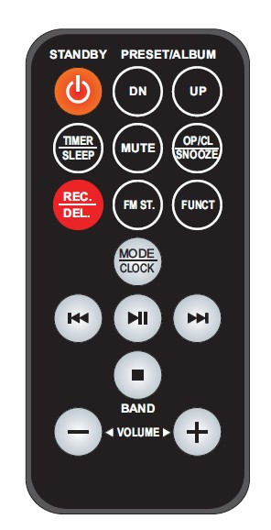THE INFRA-RED TRANSMITTER REQUIRES 1 PC CR2025 LITHUM BATTERY FOR OPERATION

## BUTTON DESCRIPTION

1. **STANDBY:** TRIGGER BETWEEN STANDBY MODE AND OPERATION MODE.
2. **PRESET/ALBUM DN:** PERFORM SAME FUNCTION AS “**ALBUM DOWN / PRESET DOWN**” BUTTON ON THE UNIT.
3. **PRESET/ALBUM UP:** PERFORM SAME FUNCTION AS “**ALBUM UP / PRESET UP**” BUTTON ON THE UNIT.
4. **TIMER / SLEEP:** PERFORM SAME FUNCTION AS “**SLEEP / TIMER**” BUTTON ON THE UNIT.
5. **MUTE**: TO MUTE AUDIO PLAYBACK.
6. **OP/CL & SNOOZE**: OPEN AND CLOSE THE CD DOOR; SNOOZE FUNCTION FOR ALARM.
7. **REC/DEL:** PERFORM SAME FUNCTION AS “**REC/DEL**” BUTTON ON THE UNIT.
8. **FM ST.**: SELECT BETWEEN FM STEREO AND MONO RADIO
9. **FUNCT**: PERFORM SAME FUNCTION AS “**FUNCTION**” BUTTON ON THE UNIT.
10. **MODE/CLOCK**: PERFORM SAME FUNCTION AS “**MODE/CLOCK**” BUTTON ON THE UNIT.
11. PLAY,PAUSE,STOP **(PLAY/PAUSE):** PERFORM SAME FUNCTION AS “PLAY,PAUSE,STOP **PLAY/PAUSE**” BUTTON ON THE UNIT.
12. PLAY,PAUSE,STOP **(STOP)/BAND:** PERFORM SAME FUNCTION AS “PLAY,PAUSE,STOP **(STOP)/BAND**” BUTTON ON THE UNIT.
13. **symbol skip 1** **(SKIP DOWN ):** PERFORM SAME FUNCTION AS “**symbol skip 1** **(SKIP DOWN )”** BUTTON ON THE UNIT. BESIDES, IT CAN BE USED FOR RADIO FREQUENCY SEARCHING DURING TUNER MODE.
14. symbol skip 2 **(SKIP UP ):** PERFORM SAME FUNCTION AS “symbol skip 2 **(SKIP UP)**” BUTTON ON THE UNIT. BESIDES, IT CAN BE USED FOR RADIO FREQUENCY SEARCHING DURING TUNER MODE.
15. **VOLUME +/- :** CONTROL VOLUME LEVEL.