**4 Port HDMI Splitter**

**AC-1710**



**User manual**

* **Introduction**

1×4 HDMI splitter distributes 1 HDMI source to 4 HDMI displays simultaneously. It offers HD video solution for HDTV/STB/DVD/Projector/DVR in homes, retail, conference room presentation, education and training, etc.

* + **Features**

1. 1 HDMI input signal split to 4 HDMI  devices.
2. HDCP 1.4 protocol compliant.
3. 3D HDMI 1.4a video format support.
4. 3D video support including Frame packing for all 3D formats up to a 297MHz TMDS clock.
5. Support display resolutions up to 4K x 2K@30Hz,1080P@120Hz,and 1080P 3D@60Hz
6. Support deep color 30bit, 36bit, 48bit per pixel.
7. Digital audio format, as DTS-HD/Dolby-true-HD/LPCM 7.1/DTS/Dolby-AC3/DSD.
   * **Package**
8. HDMI Splitter ----------------------------------------------------------------------------- 1PCS
9. 5V1A DC Power Supply adaptor ------------------------------------------------------- 1PCS
10. Operation Manual ------------------------------------------------------------------------- 1PCS
    * **Specifications**
11. Frequency Bandwidth 2.97Gbps
12. HDMI Splitter Input Ports 1 x HDMI Female input port
13. HDMI Splitter Output Ports 4 x HDMI Female output ports
14. Power Supply DC 5V 1A
15. ESD Protection Human Body Model: ± 8kV (air-gap discharge)

± 4kV (contact discharge)

1. Dimensions (mm) 70(W) X 145 (D) X 25 (H)
   * **Operation controls and Functions**

**Front Panel**

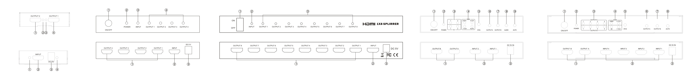

1. **ON/OFF:** Power on/off switch.
2. **POWER LED:** This red LED illuminates when the device is connected with power supply.
3. **INPUT LED:** This red LED illuminates when a HDMI signal from a source is plugged in.
4. **OUTPUT LED:** These red LED illuminates with the corresponding HDMI output port.

**Rear Panel**

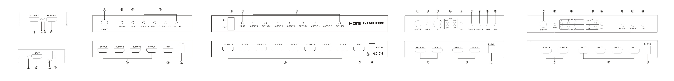

1. **HDMI OUTPUT:** These sockets connect to a HDTV or monitor with a HDMI cable.
2. **HDMI INPUT:** This socket connects to a HDMI source output, i.e. from a DVD player, Game console, etc.
3. **DC 5V:** Plug the 5V DC power supply into the unit and connect the adaptor to AC wall outlet.
   * **Application Example**

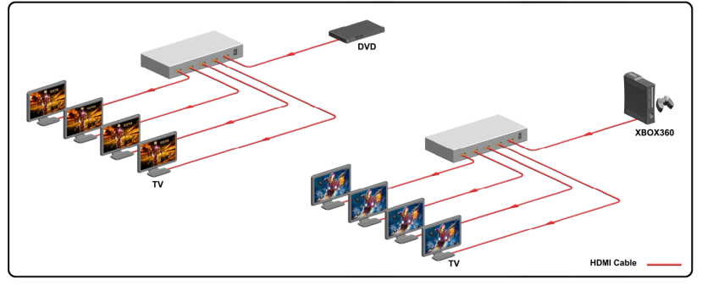

**IMPORTANT:**

- Never attempt to open, repair or modify any part of this unit or its accessories.

- Never get any part of the device or its accessories wet.

- Failure to adhere to these points will result in a void of warranty.